Lab 01 Answers

1.

2. mrsAdams, r2_d2, Hal9000

3.

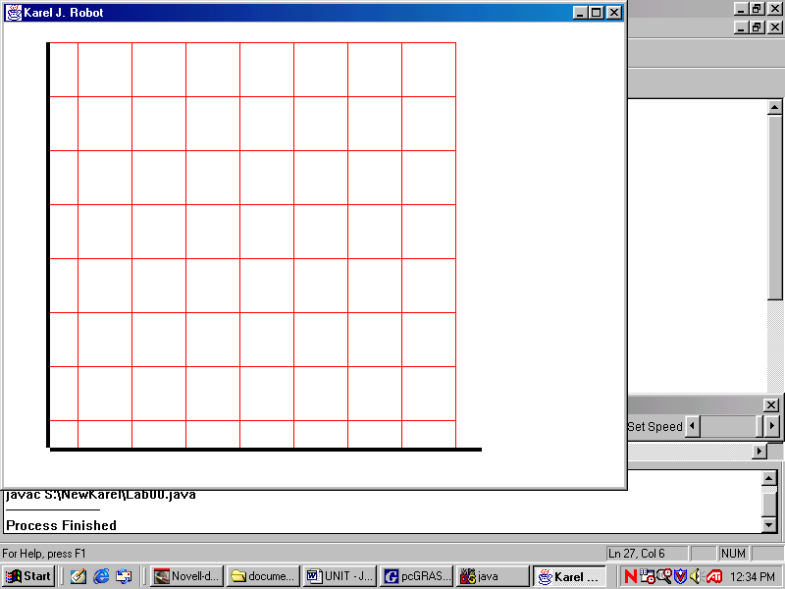

4. 8x8

5. Display.setSize(8, 8);

6. Nouns: Lisa, teacher, students, pete,

Verbs: needs, store, takes, wait, help, gives,

7. Nouns turn into identifiers.

8. Verbs turn into commands

9.

10.

11.